**Project 6 -- Final Project (82/100)**

**Documentation (10/10)**

· Readme is good.

o Directions provided in Readme result in **Webpacker::Manifest::MissingEntryError in Main#index** error.

§ I had to remove a line of code from /app/views/layouts/application.html.erb.

§ Charlie said not to worry about this, webpacker is dumb.

· Git commits are good.

· In-code documentation is good.

**Correctness + Testing (18/30)**

· 13 errors in tests. **-2**

· As an admin, attempting to create a course results in this error. **-5**

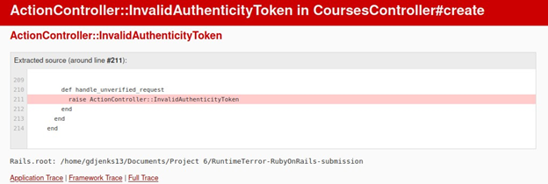

· I also get an error when trying to logout. “No route matches [GET] “/logout” **-5**

· Everything else works correctly that I could test because these are major problems that limit testing.

**Functionality/Features (21/25) -4**

· Ability to submit and view scores for classmates within a team, supports multiple projects

· **Can’t test the ability to populate a class because I cannot log in and out**.

o From the seeded data, seems possible.

· Admin interface can view group scores.

· There is login, but logout does not work properly.

· Students can belong to multiple groups. That is structured nicely.

· Students can join and leave a course.

**Aesthetics (8/10)**

· The header is simple and easy to follow. Buttons in header are useful and CSS styling is effective.

· Text is generally small and hard to read, not very accessible. **-2**

· Information is displayed in an order that makes sense

**Style – HTML/CSS/JS (8/8)**

· Good job

**Style – Ruby (7/7)**

· Good job

**Design – HTML/CSS/JS (5/5)**

· Good job

**Design – Ruby/Rails (5/5)**

· Schema design is well defined in the Readme and is functionally solid.

· Models are very well designed.